## **Download and install MySQL database server**

You can download the [MySQL community server](https://dev.mysql.com/get/Downloads/MySQLInstaller/mysql-installer-community-8.0.19.0.msi). Once the installer has been downloaded, double-click the setup file to start the installation process. On the **Choosing a Setup Type** page, you can see four installation options.

1. **Developer default:** If you want to create a development machine, you can use this option. It installs the components which are required for application development, e.g., MySQL Server, MySQL Shell, MySQL connectors, MySQL
2. **Server Only:** If you want to create a standalone database server with specific components, you can use this option
3. **Full:** If you want to install MySQL Server with its all components, then you can use this option
4. **Custom:** If your requirements are limited to the few components, you can use this option

We are going to install MySQL Server with all components; hence, choose “Full” and click on Next.

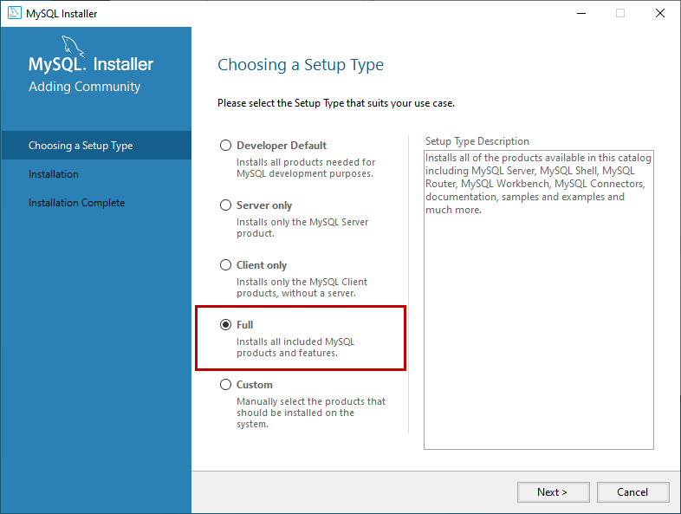

Before installation begins, the installer checks all the prerequisites that are required to install all the components of the MySQL database server. If any software prerequisites are missing, then you can see the details of failing requirements on the **“Check Requirements'' screen**. It shows the name of the product, required component/software, and its status. As you can see, to install the MySQL database server for visual studio, we must install visual studio 2015 or above. Similarly, to install a Python connector, we must install python on the workstation. Click on **Next**.

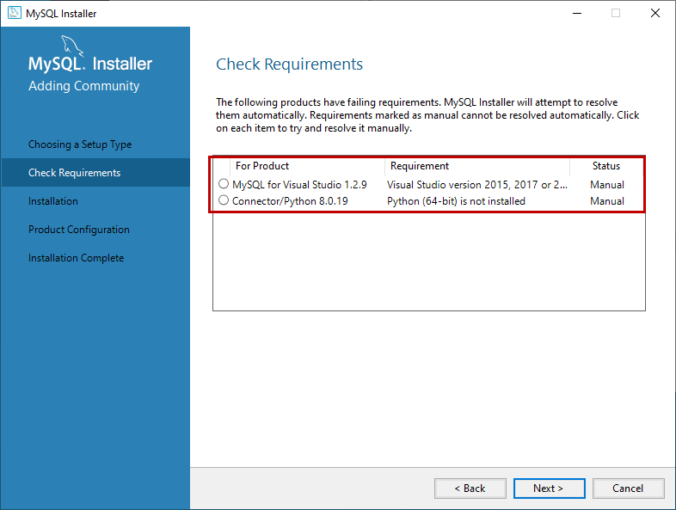

An installer gives us a warning. We can continue our installation without installing the visual studio and python. Click on Yes.

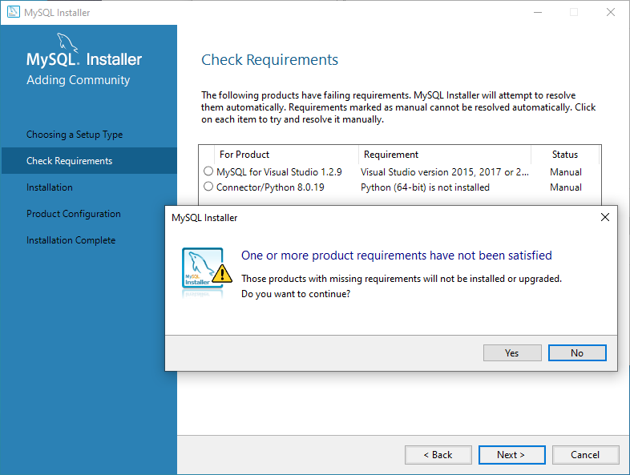

On the Installation screen, you can see the list of the MySQL products/software that are going to be installed on my workstation. Review the list and click on Execute.

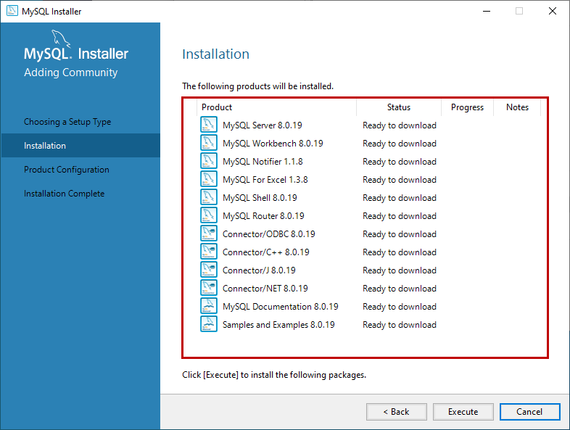

The installer downloads all the products/software. After that, it installs all the products.

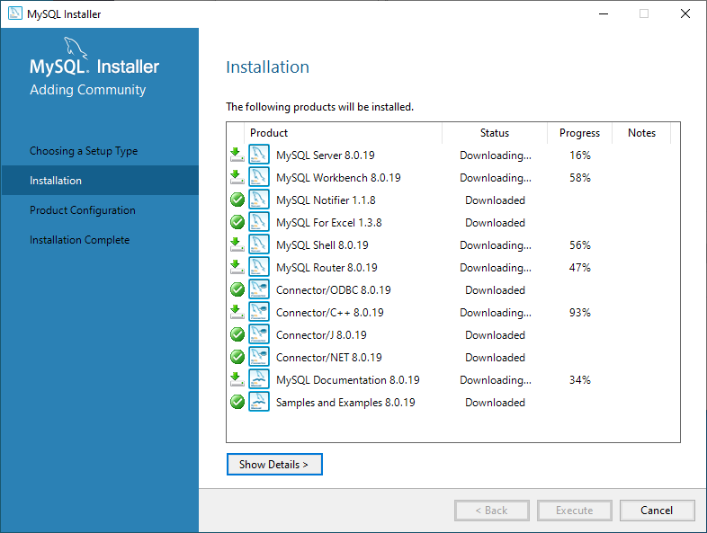

Wait for a few mins. Once the installation process completes, we are ready to configure the MySQL database server and other components. Click on Next.

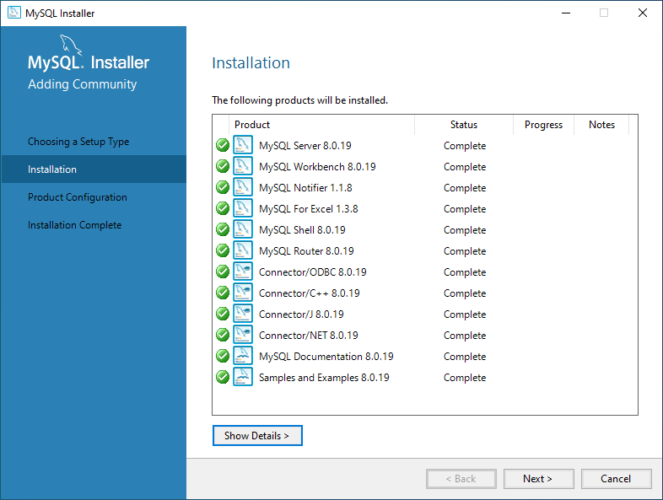

On the Product configuration screen, you can see the list of the products that need to be configured. First, let us configure the MySQL Server. Click on **Next**.

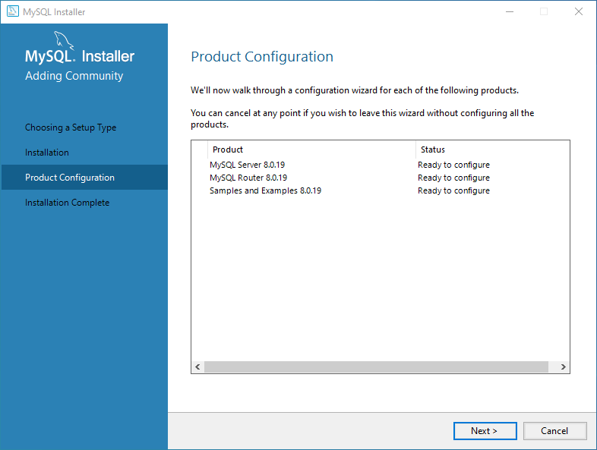

On the High availability screen, we can choose to install the **InnoDB cluster** or **Standalone MySQL Server**. **InnoDB cluster** is the High availability solution of MySQL. It uses group replication. I will explain more about it in my future series of articles. We are going to perform a standalone installation of MySQL Server hence choose “**Standalone MySQL Server / Classic MySQL Replication**”.

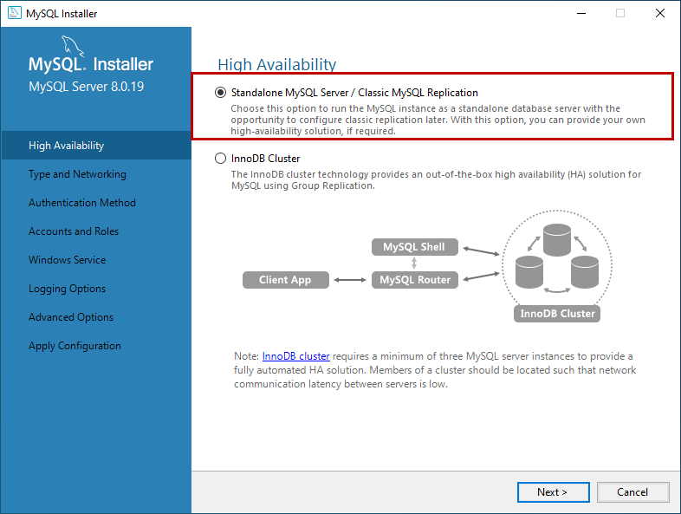

On **Type and Networking** screen, we can configure the following:

**The type of MySQL configuration.**

**The type of MySQL configuration** is a predefined set of configuration parameters that determines how much resources should be allocated to the MySQL Services. You have three configuration options:

1. **Development Computer:** This configuration uses a minimal amount of the resources to MySQL Service
2. **Server Computer:** This configuration uses a minimal amount of resources. This option is suitable when we are installing database servers and web servers on the same machine. The configuration allocates an average amount of resources to MySQL Service
3. **Dedicated Computer:** This option is used when we have created a dedicated MySQL Server. The configuration allocates a high amount of resources to MySQL Service

We would configure the server with minimal resources hence select “Development computer” from the Config Type drop-down box.

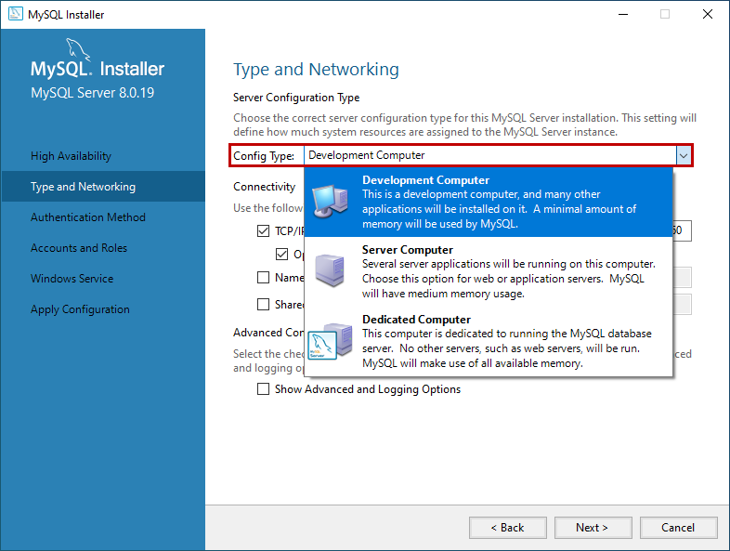

**Network Connectivity**

In this section, we can control how clients can connect to MySQL databases. We can use TCP/IP protocol or Named Pipe or Shared Memory. If you want to configure Named Pipe / Shared Memory, we must provide the Pipe Name and Memory Name. You can also specify the default port to connect to the database server. You can also choose to allow the port number specified in the Port textbox in the firewall. See the following image:

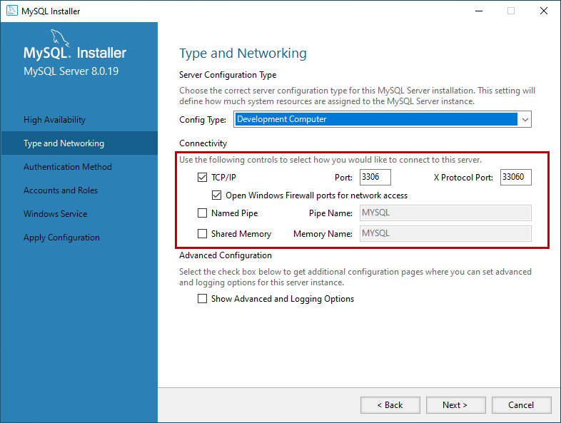

In MySQL 8.0 version, we can use SHA256 based strong passwords. On the **Authentication Method** screen, choose the option to use the Legacy authentication method or Strong password for authentication. Note: If you are using **Strong Password Encryption for Authentication,** then make sure that all the connectors must be updated to the latest version. We are going to use **Strong password Encryption for Authentication**.

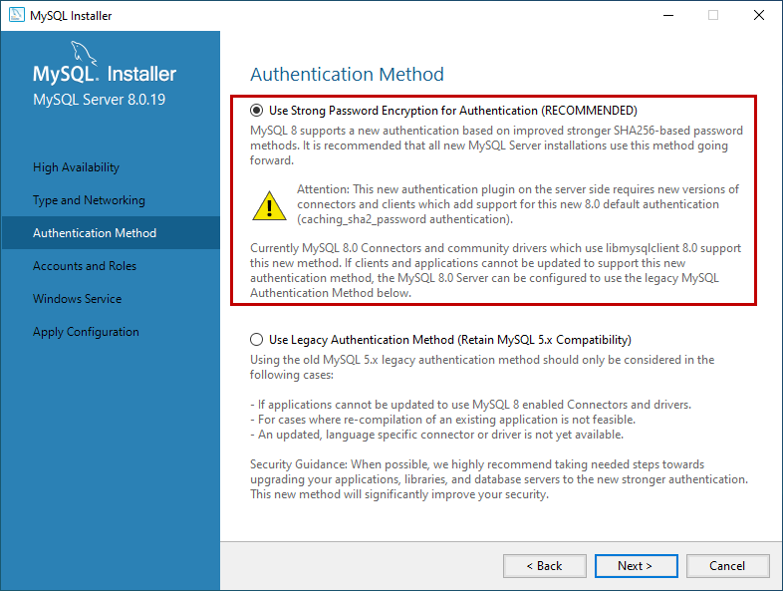

On the Accounts **and Roles** screen, you can specify the MySQL root account password. MySQL Root account is a default sysadmin account, and it must be disabled.

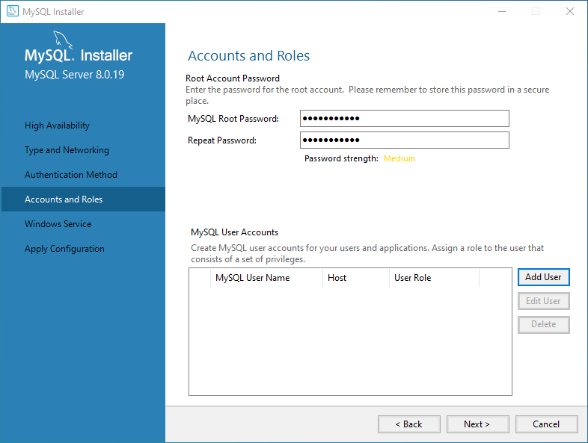

On the **Windows Service** screen, you can configure the MySQL server to run as a windows service. You can provide the desired name and configure it to auto-start the service when the system reboots. Moreover, you can provide the credentials under which the MySQL Service will run. You can choose the standard system account or provide a specific user. See the following image:

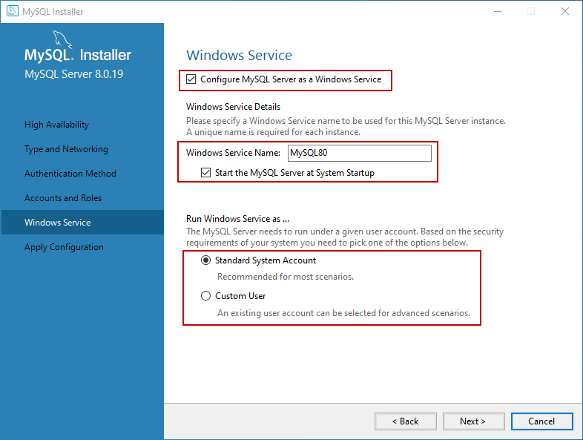

On the **Apply Configuration** screen, you can see the list of confirmation steps. Once all the configuration settings are verified, click on **Execute**.

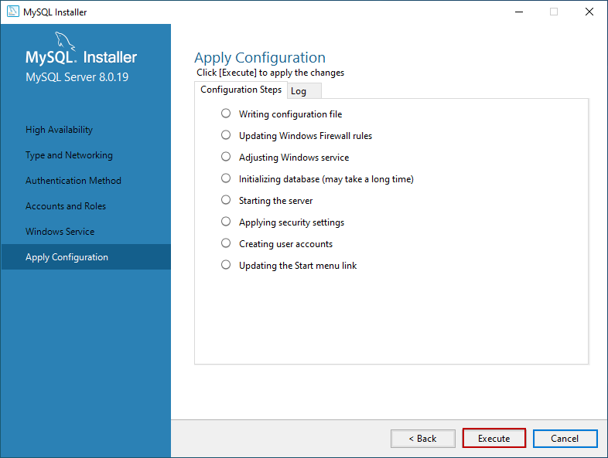

The MySQL installation process starts. You can view the installation process in the “Log” tab. Once installation completes successfully, click on “**Finish**” to close the installer.

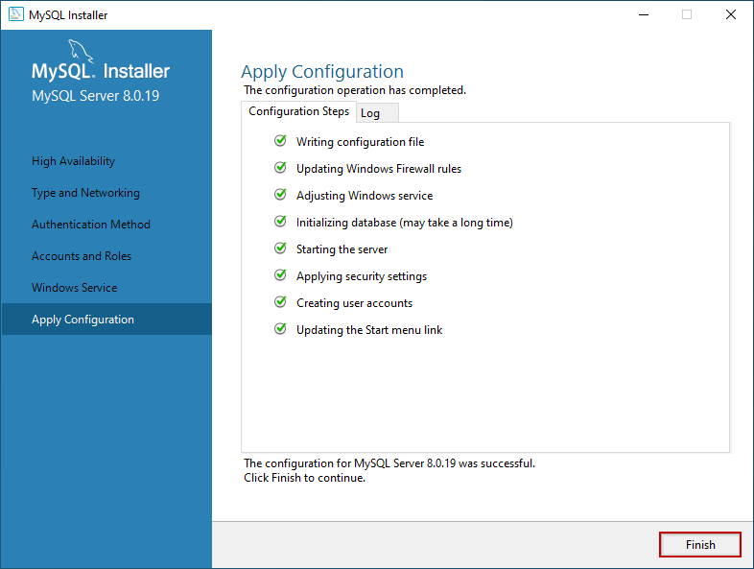

## **Install the sample database**

If you have chosen to install all the components of MySQL Server (Full Setup Type), MySQL installer moves to Sample and Example screen. On this screen, provide username and password of the user that has root/sysadmin privileges and click on Check. If the connection established successfully, click on next. See the following image:

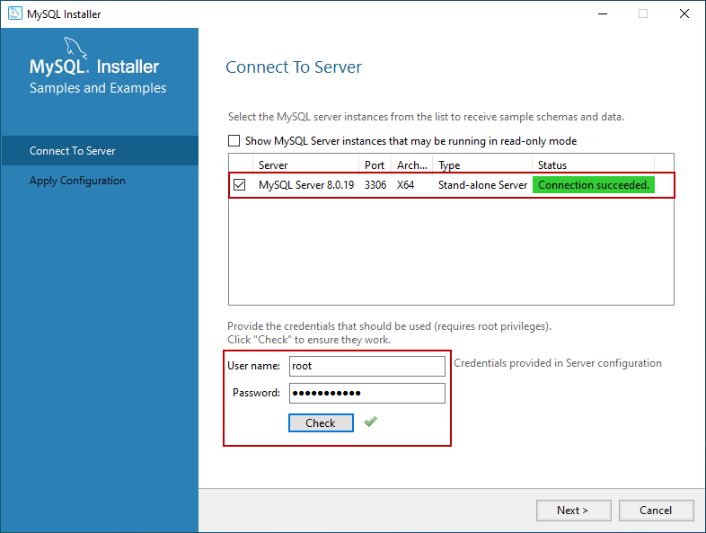

On the **Apply Configuration Screen**, click on **Execute** to start the installation of the Sample database. See the following:

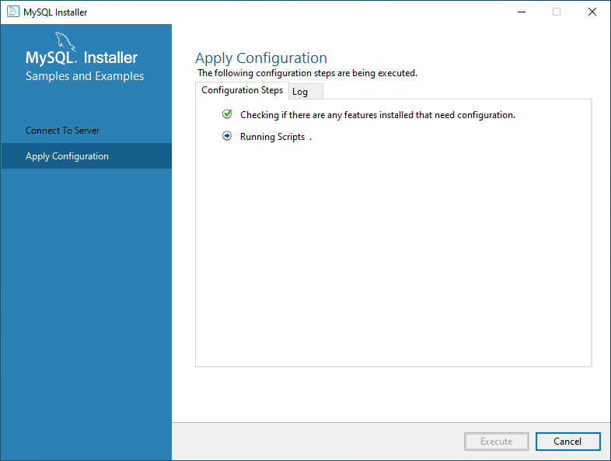

Once the sample database has been installed, click on the **Finish** button.

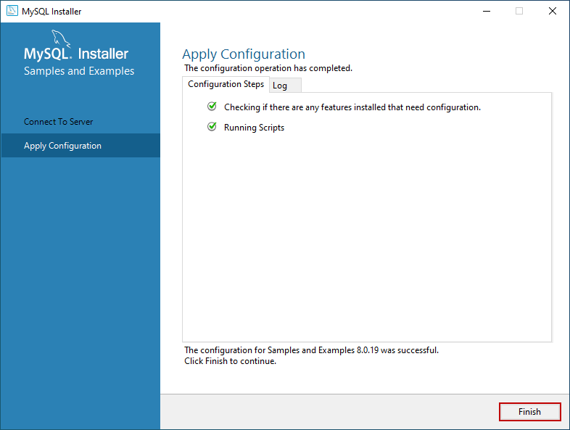

The installer continues to the **Product Configuration** screen. On this screen, you can see that the installation of the **MySQL Server 8.0.19** and **Sample and Example 8.0.19** has been completed successfully. See the following image:

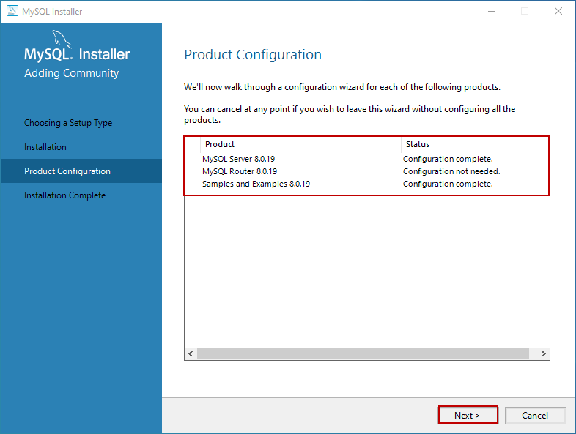

Once the installation completes, you can copy the installation logs on the clipboard to review it later. Moreover, if you want to start exploring MySQL straight away, then you can select “**Start MySQL workbench after Setup**” and “**Start MySQL Shell after Setup**” and click on **Finish**. See the following image:

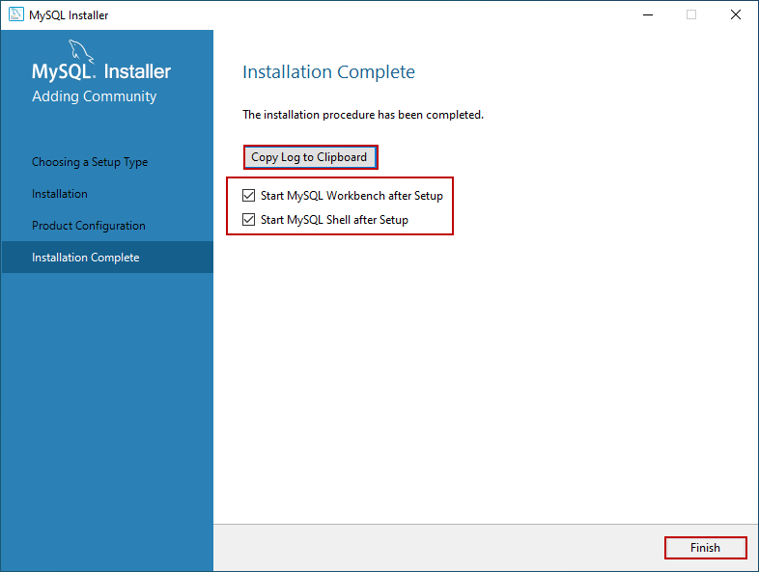

## **Connect to MySQL Server**

Once the installation completes, let us connect to the server and execute the first MySQL Query. Open MySQL workbench. Just like SQL Server management studio, MySQL workbench is the development tool which is used to query the database and create database objects.

On the MySQL workbench welcome screen, you can see the list of MySQL connections. We have not configured multiple connections; hence you can see “**Local instance MySQL80.**” Click on it to open the new query editor window.

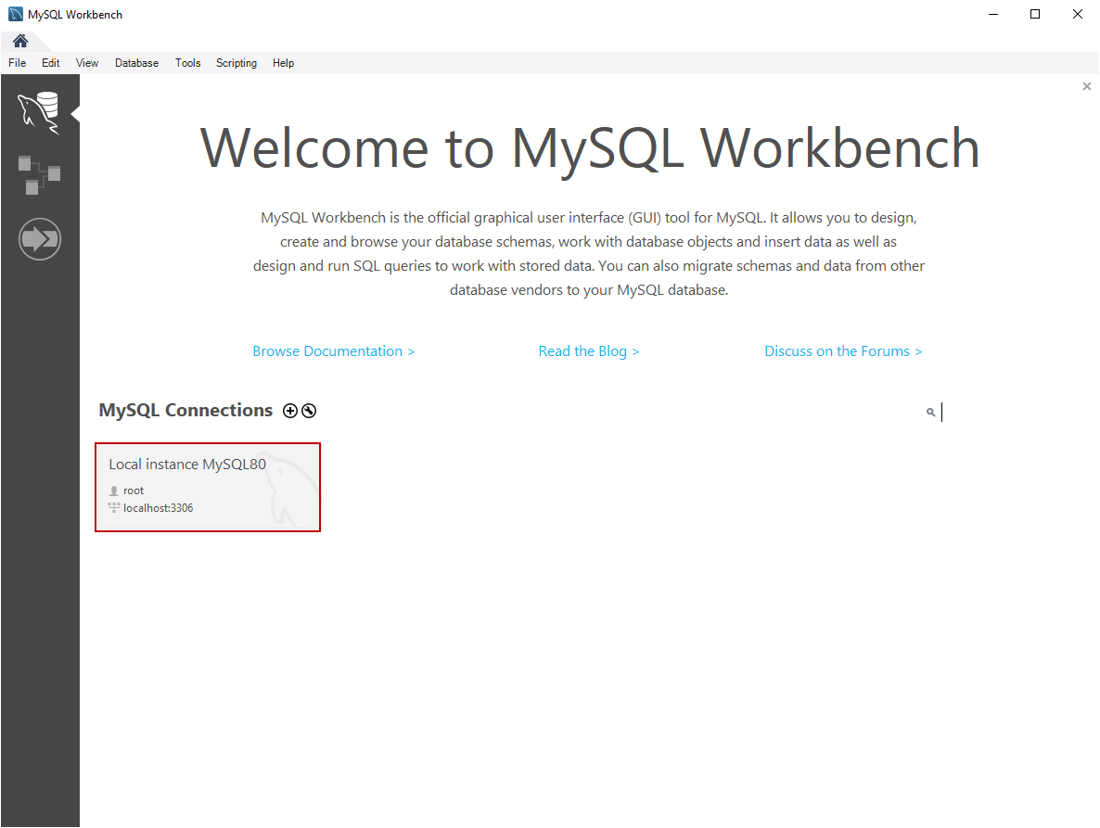

When you click on the connection, you must enter the credentials to connect the database server. Enter the password and click on OK.

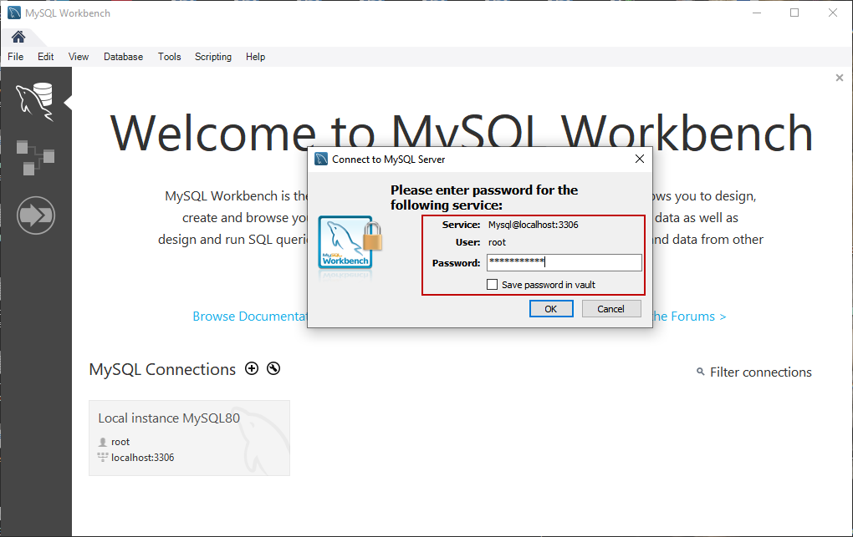

First, let’s create a simple database on MySQL Server. Write the following query in the query editor window and click on execute. See the following image:

|  |
| --- |
| create database demo |

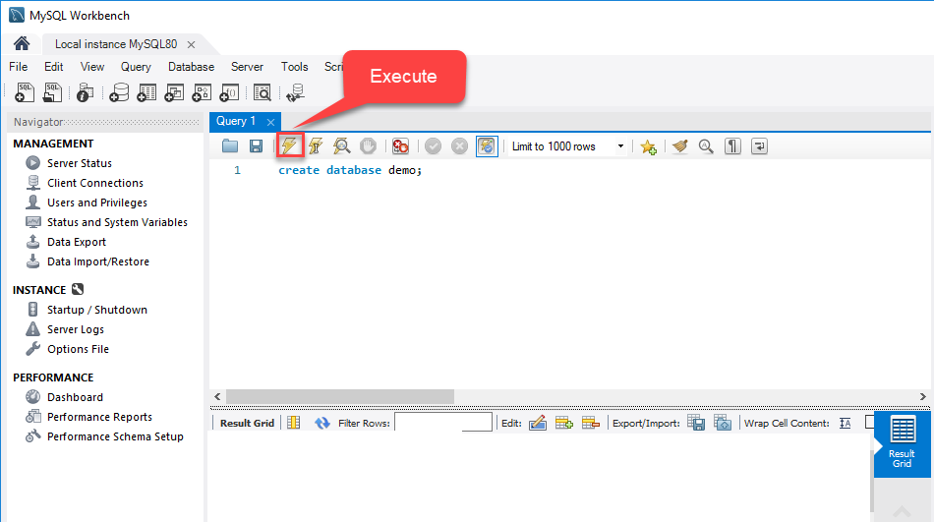

Once the query executes successfully, you can see the new database in the “SCHEMAS” pan. See the following image:

